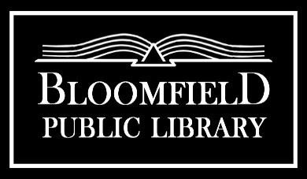 | 9 Church Street  Bloomfield, NY 14469  585-657-6264  www.bloomfieldpubliclibrary.org

ALCOHOLIC BEVERAGE POLICY
Adopted: 10/15/1028. Revised 4/17/2023.

Alcoholic beverages may be served at the Bloomfield Public Library ("Library") in compliance with this policy and any applicable federal, state or local law or regulation

Any alcoholic beverage served on Library premises must be free of charge. No alcoholic beverage may be served at any Library event in which there is an admission fee or charge required of the invited guests to participate in the event.

No alcoholic beverages may be served except during such times as there is host liquor liability insurance in effect, approved by the Library's Board of Trustees ("Board"), and covering the Library, its employees, and trustees. Alcoholic beverages will be limited to wine, beer, and hard cider that may be served at Board approved Library events.

Prior official approval of the Board will be required for any Library event or events in which alcohol will be served.

Library events in which alcohol is approved to be served on Library premises will be limited to no more than twelve events in a calendar year. Library events that include alcoholic beverages will be limited to a single two-hour period.

Those offering or serving any alcoholic beverage at Board approved Library events shall be of legal age, and shall not be a Library employee, Library staff, or Board member.

Those offering or serving alcoholic beverages at Board approved Library events shall not be under the influence of alcohol while serving alcoholic beverage to guests, and may refuse service to attendee(s) under the influence of alcohol if deemed appropriate or necessary.

The Library reserves the right to require any person to cease consuming any further alcoholic beverage, or to leave the Library premises, or both, if it determines, in its sole and absolute discretion, that the behavior of such person is, or appears to be, adversely impaired due to the influence of alcohol.

Attendees at Board approved Library events in which alcoholic beverages are offered, served, or consumed, shall be of legal age and shall provide legal documentation of such upon request.

Non-alcoholic beverages will be available as an alternate to alcoholic beverages being served at Board approved Library events.

Food will be available at any Library event in which alcoholic beverages are approved to be served.

The cost of any alcoholic beverages shall not be directly or indirectly borne by the Library.

This policy will be reviewed periodically by the Board.

