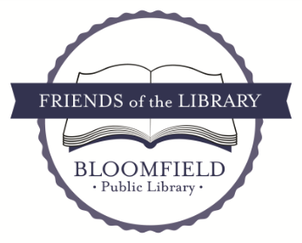

We are a volunteer non-profit organization of individuals and families who believe our public library is a very special place that provides a vital community service. As a member of the Friends, you help support the library through advocacy, fundraising, and giving back to your community. New Friends are always needed and welcomed at various library programs and events. We appreciate your financial support as well as your volunteer time, no matter how big or how small!
Annual membership extends April 1,2024 to March 31,2025.
Please take a moment to complete and return the bottom portion of this form and become a Friend of the Bloomfield Public Library or renew your membership today. Every dollar goes towards additional programs, services, materials, and supplemental financial support that the library budget is unable to provide.

New membership _____ Renewal ______ Donation _____

I/ We request to be a Friend of the Bloomfield Public Library for 2024-2025:
- Single $10
- Family $15
- Supporting $30
- Corporate sponsor $100
Name:_______________________________________________________________________________
Address:_____________________________________________________________________________
______________________________________________________________________________
Phone: (best contact number): _________________________________________________________________
Email: ______________________________________________________________________________
(Used for Friends’ communications. Your email will not be shared, nor will we bombard you with emails.)

I would like to learn more about volunteering with the FRIENDS: ______
I am interested in the following: (please circle all your areas of interest):
Community events and festivals (represent the library)
Volunteer at programs such as Ice-cream Social & Summer Reading programs
Advocacy activities (legislative events) Community connections
Marketing Fundraising Project management Membership Book Sale
Share clerical skills Refreshments Holiday decorating Chicken BBQ
Share special talents Other (please specify)____________________________________

Make checks payable to: Friends of the Bloomfield Public Library or send
an online donation to: https://paypal.me/FOTLbloomfieldny

Please return this form with your payment to: Friends of the Bloomfield Public Library
9 Church St, Bloomfied, NY 14469

We thank you for your support.

